**EXPERIMENT NO. 9**

Simulation of FIR and IIR filter using FDATOOL in MATLAB.

**EXPERIMENT NO. 9**

**OBJECTIVE:** To explore fdatool and simulink in MATLAB and design FIR and IIR filter using same.

**SOFTWARE USED:** MatlabR2014a

**THEORY:**

The Filter Design and Analysis Tool (FDATool) is a powerful graphical user interface (GUI) in the Signal Processing Toolbox™ for designing and analyzing filters.

FDATool enables us to quickly design digital FIR or IIR filters by setting filter performance specifications, by importing filters from your MATLAB® workspace or by adding, moving or deleting poles and zeros. FDATool also provides tools for analyzing filters, such as magnitude and phase response plots and pole-zero plots.

**Optimizing the Design**

To minimize the cost of implementation of the filter, we will try to reduce the number of coefficients by using minimum order option in the design panel. we change the selection in filter order to minimum order in the design region and leave the other parameters as they are.

**Exporting the Filter**

Once we are satisfied with our design, we can export our filter to the following destinations:

MATLAB workspace , MAT-file , Text-file, Simulink model.

**Generating an M-File**

FDATool allows to generate M-code to re-create our filter. This enable to embed our design into existing code or automate the creation of our filters in a script.

**Simulink**

Simulink, developed by The MathWorks, is a commercial tool for modeling, simulating and analyzing dynamic systems. Its primary interface is a graphical block diagramming tool and a customizable set of block libraries. It offers tight integration with the rest of the MATLAB environment and can either drive MATLAB or be scripted from it. Simulink is widely used in control theory and digital signal processing for simulation and design. Simulink contains a library editor of tools from which we can build input/output devices and continuous and discrete time model simulations. To open Simulink, type in the MATLAB work space - >>simulink

Simulink opens with the Library Browser.  Library Browser is used to build simulation models.

**Output:-**

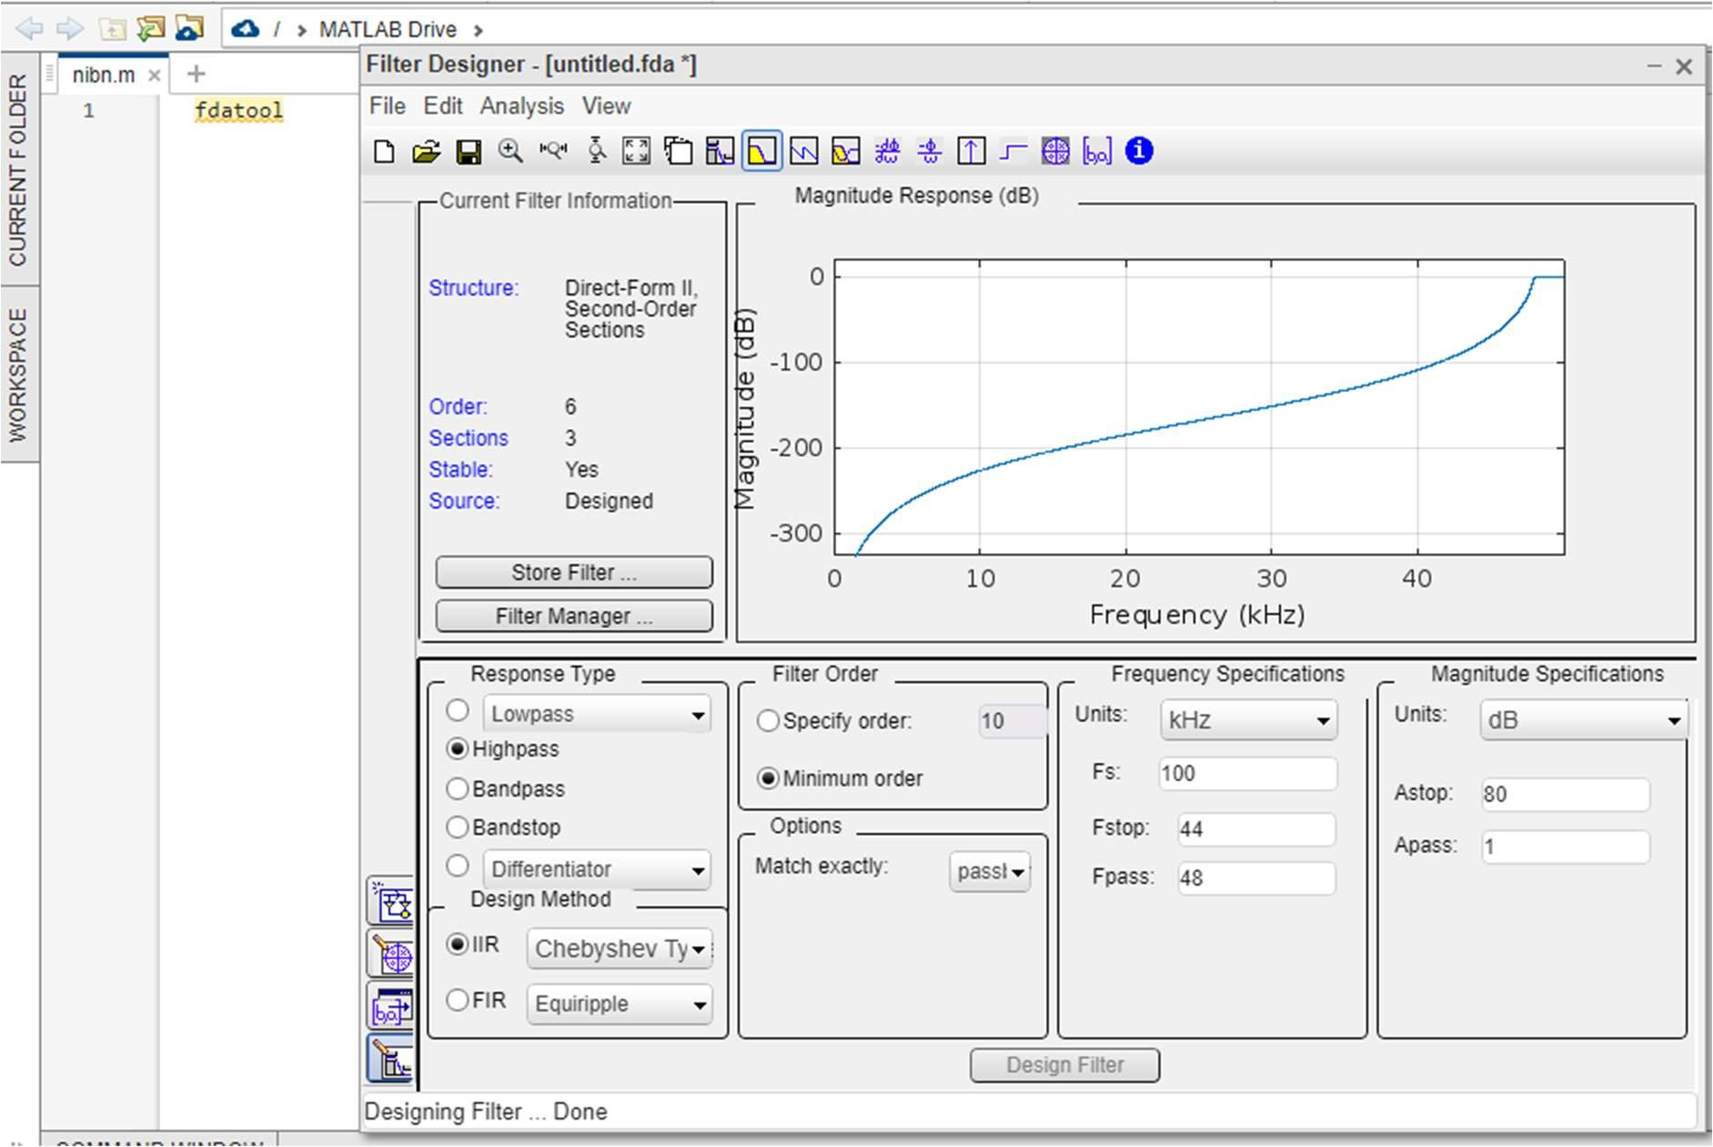

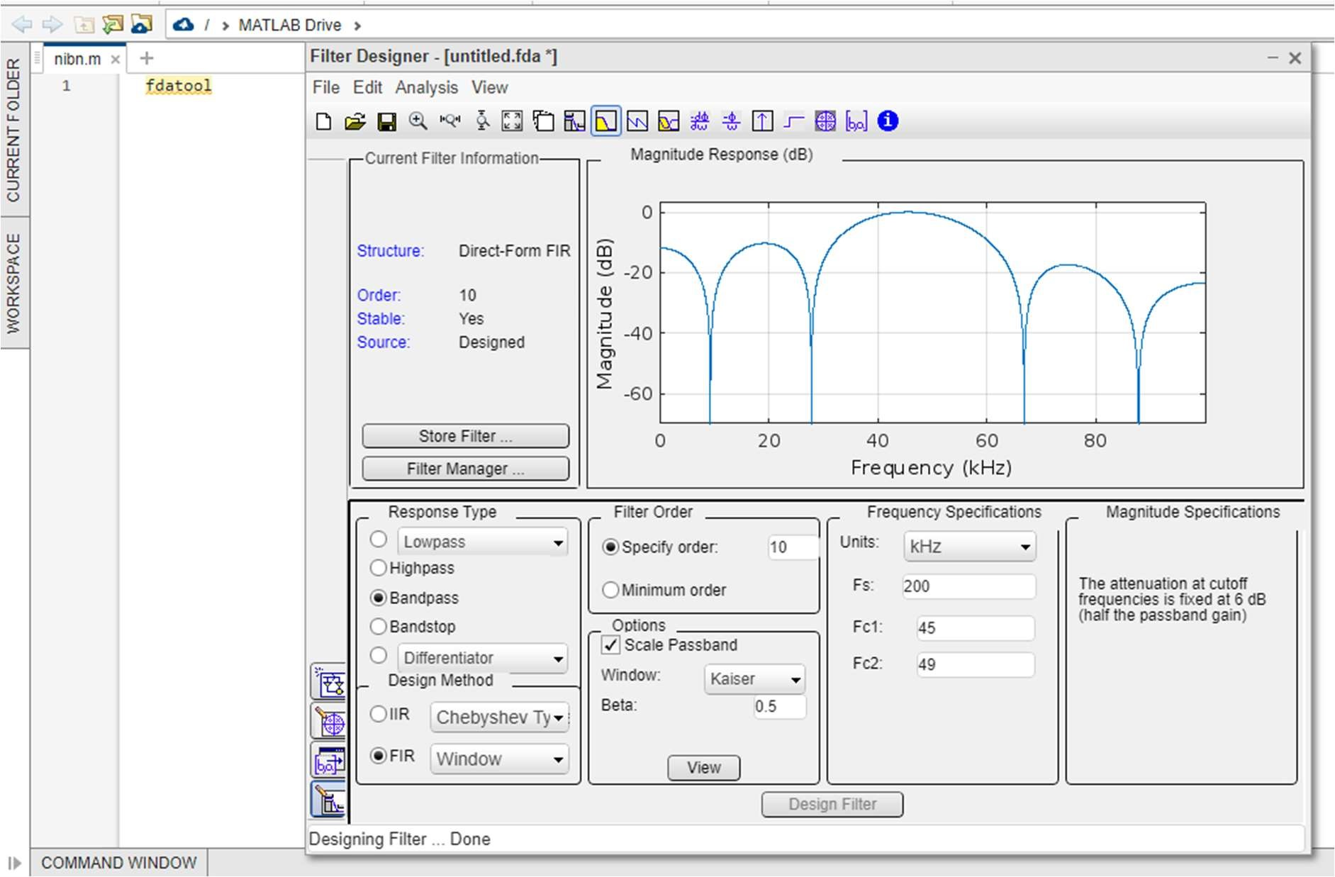

**CONCLUSION:**

**The use of fdatool and Simulink in matlab was understood. Designing of FIR and IIR filter using matlob was performed successfully.**